App: Colours: Phase #1

Date: Feb 27th, 2023  
Domain: <https://colours.brickmmo.com>

GitHub: <https://github.com/codeadamca/brickmmo-colours>

# Application Purpose:

This application will provide a series of tools related to the official LEGO™ colour palette. This will include a small website for visitors to browse, search, and convert colours as well as an API for other BrickMMO applications to incorporate the LEGO ™ colour palette.

# Front-End:

Front end facing application will include the following features:

* Browse LEGO™ colour palette
* Search for LEGO™ colours using colour keywords
* Convert existing colours from text, CMYK, or RGB to the LEGO™ colour palette

Application will include similar UI and features to this HTML Symbols tool:

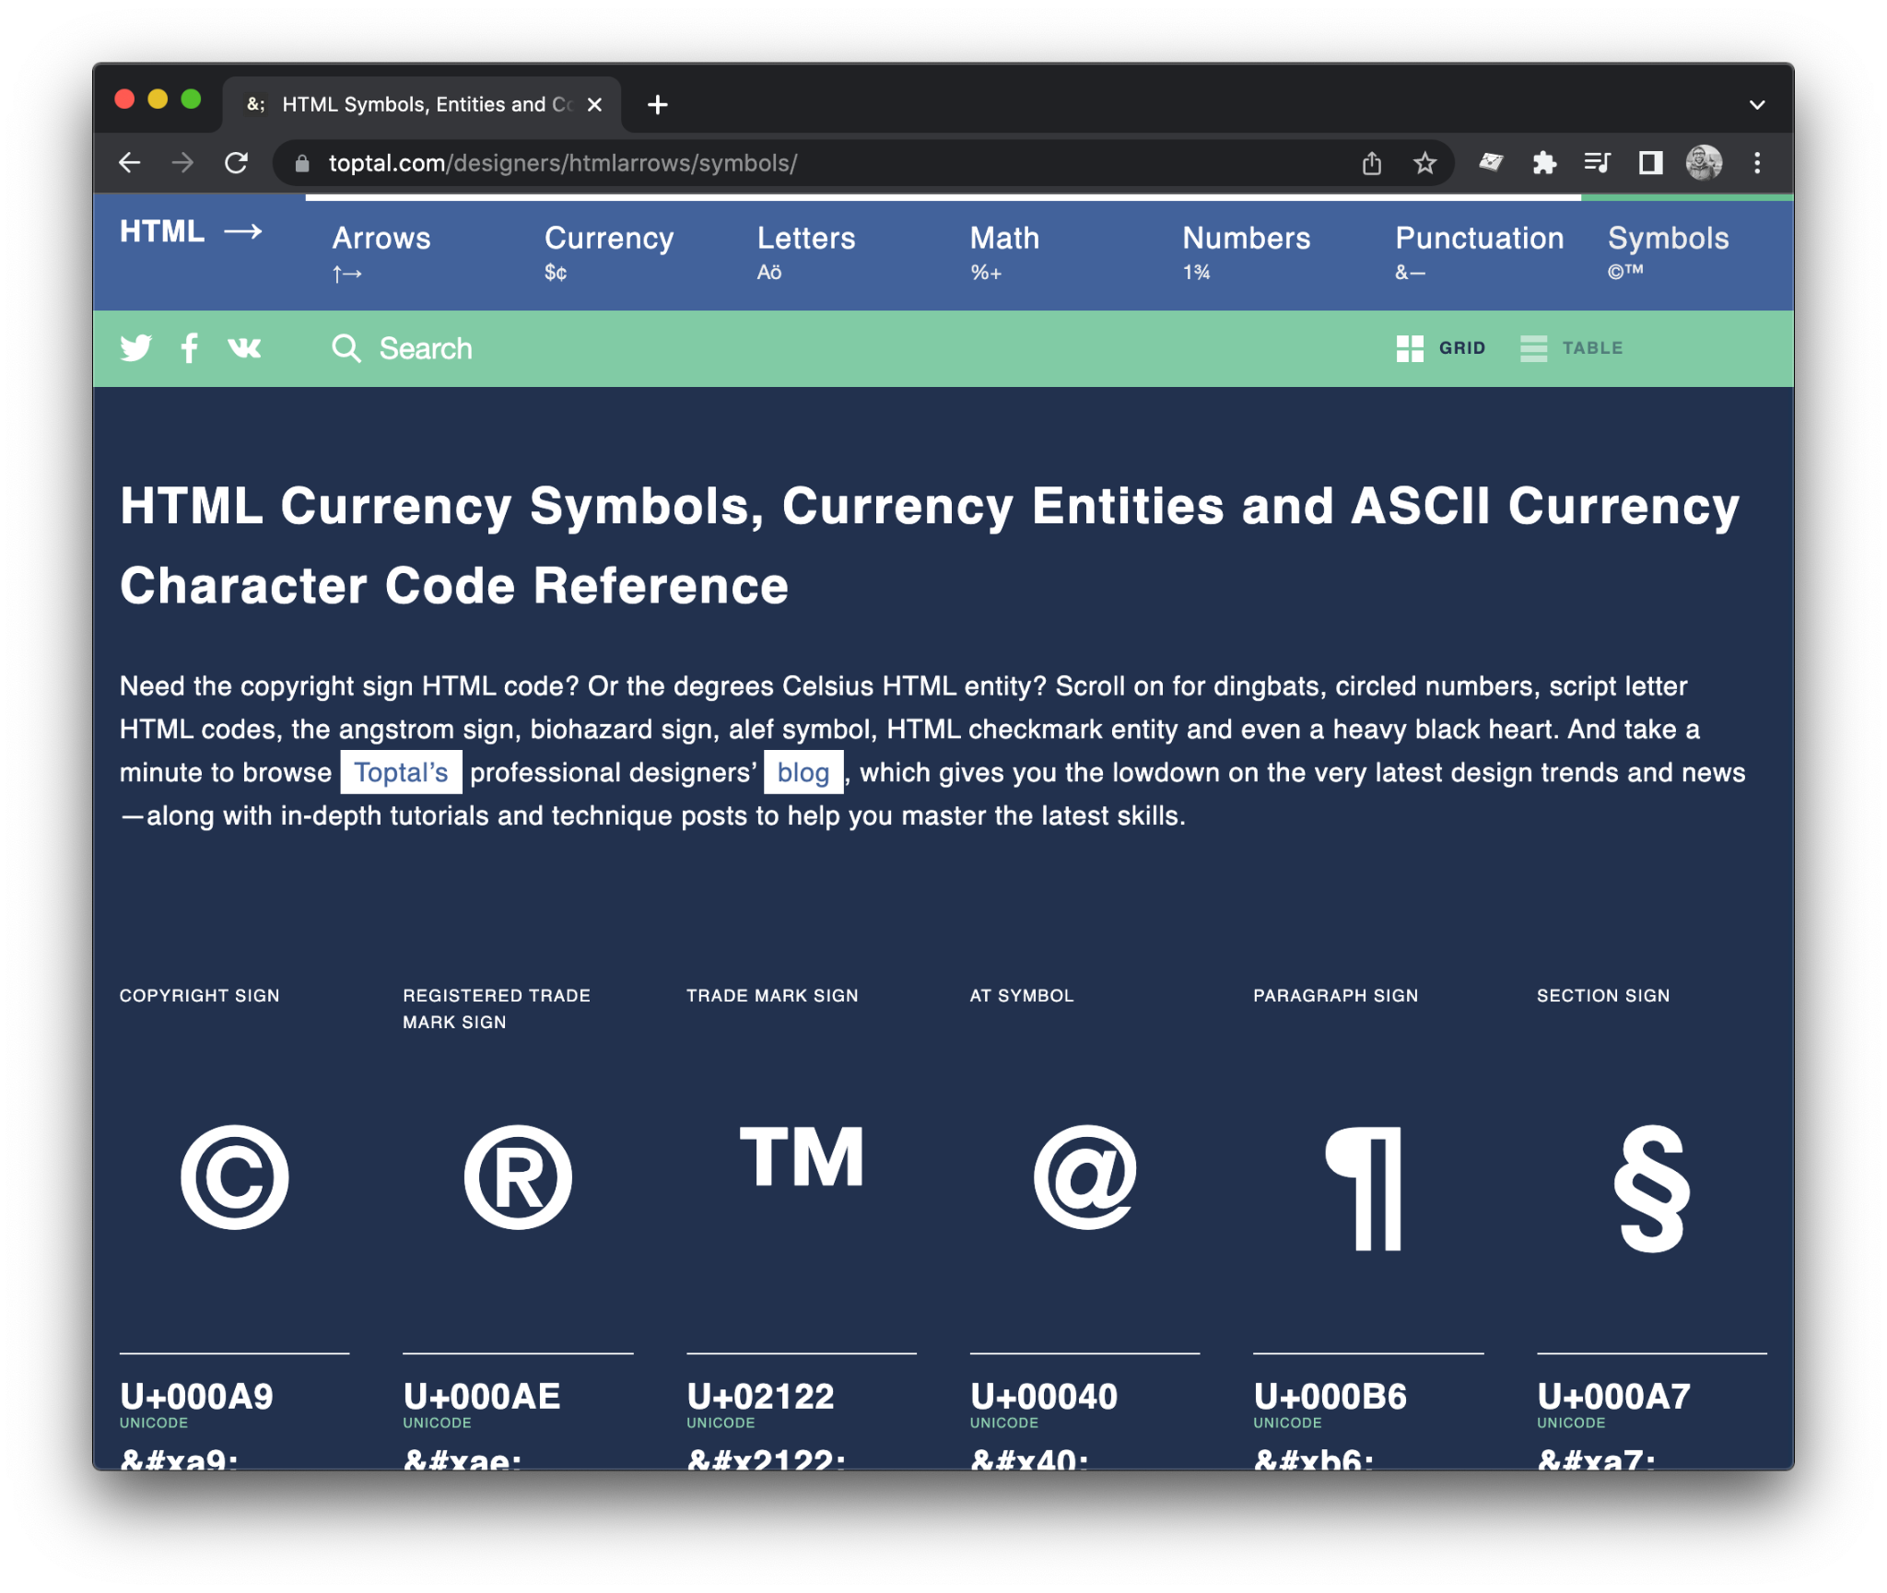

<https://www.toptal.com/designers/htmlarrows/symbols/>

# Back-End:

Application will include a control panel to achieve the following:

* Login to control panel
* Add, edit, and delete LEGO™ colours
* Import LEGO™ colour palette from ReBrickable API:  
  <https://rebrickable.com/api/>

# API:

Application API will include the following API calls:

| **Method** | **Endpoint** | **Description** | |
| --- | --- | --- | --- |
| GET | /api/colours | A list of colours.  **Returns:**  A list of all LEGO™ colours. Each colour will include ID, name, RGB, CMYK, transparency, BrickLink ID, and BrickLink name. | |
| POST | /api/convert | Converts a specified colour to a LEGO™ colour palette colour.  **Parameters:** colour (required): RGB, CMYK, or text colour  **Returns:**  A single colour including ID, name, RGB, CMYK, transparency, BrickLink ID, BrickLink name, a match distance. | |